Section 1: Case Summary

Scenario Title: | COVID-19: STEMI and VF Arrest
Keywords: | COVID, STEMI, Ventricular Fibrillation, Cardiac Arrest
Brief Description of Case: | Ronda is a 50 yo patient who presents with 1.5 hours of typical cardiac chest pain. She has known COVID positive contacts and mild URTI symptoms. The ECG shows an anterior STEMI. The team will need to perform initial work-up and management of a patient with STEMI. While this is occurring, the patient suffers a VF arrest. The team will need to go through the ACLS algorithm while taking all precautions required in caring for a patient with suspected COVID.

Goals and Objectives
Educational Goal: | To practice effectively caring for a COVID positive patient presenting with STEMI and VF arrest while protecting the safety of the healthcare team.
Objectives:  (Medical and CRM) | - Recognize a COVID risk patient and sequester and protect team with appropriate PPE  - Recognize and treat a STEMI that unexpectedly progresses to VF arrest  - Demonstrate effective communication and resource allocation in a COVID suspected patient requiring urgent intervention  - Demonstrate effective donning and doffing of PPE  - Utilize protective measures in a suspected COVID patient in cardiac arrest
EPAs Assessed: | N/A

Learners, Setting and Personnel
Target Learners: | ☐ Junior Learners |  | ☐ Senior Learners |  |  | ☒ Staff
 | ☒ Physicians | ☒ Nurses |  | ☒ RTs | ☒ Inter-professional
 | ☐ Other Learners:
Location: | ☒ Sim Lab |  | ☒ In Situ |  |  | ☐ Other:
Recommended Number of Facilitators: | Instructors: 1
 | Confederates: 0
 | Sim Techs: 1

Scenario Development
Date of Development: | March 29, 2020
Scenario Developer(s): | Krista Dowhos, MD, Family Medicine Resident, Alim Nagji MD CCFP(EM)
Affiliations/Institutions(s): | McMaster University
Contact E-mail: | krista.dowhos@medportal.ca
Last Revision Date: | April 2, 2020
Revised By: | Chris Heyd
Version Number: | 1

Section 2A: Initial Patient Information

- Patient Chart
Patient Name: Ronda Smith |  |  |  | Age: 50 | Gender: F | Weight: 70 kg
Presenting complaint: Chest pain
Temp: 36.8 ºC | HR: 88/min | BP: 148/80 |  | RR: 18/min | O₂Sat: 98% | FiO₂: RA
Cap glucose: 7 mmol/L |  |  |  | GCS: 15 (E4 V5 M6 )
Triage note: 50 yo female with 1.5 hours of chest pain and L arm heaviness. 2 days of mild URTI symptoms. Contact with COVID patients at LTC home, where the patient works. EKG not done at triage.

Allergies: NKDA
Past Medical History:  HTN  Hypercholesterolemia |  |  | Current Medications:  Lipitor 40 mg daily  Ramipril 5 mg daily

Section 2B: Extra Patient Information

A. Further History
Include any relevant history not included in triage note above. What information will only be given to learners if they ask? Who will provide this information (mannequin’s voice, confederate, SP, etc.)?

Patient (mannequin’s voice) gives following information if asked by learners:
Ronda is a 50 yo patient who presents with 1.5 hours of typical cardiac chest pain. She has known COVID positive contacts and mild URTI symptoms. She works as a nurse at a LTC home. She has had a cough for 2 days. She also has a runny nose. She does not have hemoptysis. It is hard to take a deep breath. She had subjective chills yesterday. She has been self-isolating for the last 24 hours.
B. Physical Exam
List any pertinent positive and negative findings
Cardio: normal heart sounds and pulses | Neuro: normal
Resp: good a/e bilaterally, no crackles or wheeze | Head & Neck: normal
Abdo: soft, non-tender | MSK/skin: diaphoretic
Other:nil

Section 3: Technical Requirements/Room Vision

A. Patient
☒ Mannequin (specify type and whether infant/child/adult) – adult, computerized mannequin
☐ Standardized Patient
☐ Task Trainer
☐ Hybrid
B. Special Equipment Required
PPE: gown, N95 mask, faceshield, gloves
Nasopharyngeal swab
Defibrillator and pads
LMA
Intubation materials, including viral filter
HEPA filter for room

C. Required Medications
ASA, nitro spray, ticagrelor/clopidogrel, opioids/pain medication, heparin
ACLS medications

D. Moulage
Diaphoresis spray

E. Monitors at Case Onset
☐ Patient on monitor with vitals displayed
☒ Patient not yet on monitor
F. Patient Reactions and Exam
Include any relevant physical exam findings that require mannequin programming or cues from patient
(e.g. – abnormal breath sounds, moaning when RUQ palpated, etc.) May be helpful to frame in ABCDE format.
A – Airway protected, patient talking.
B – Spontaneous breathing, hard to take a deep breath. Good air entry bilaterally, no crackles or wheezes on auscultation. No cyanosis.
C – Extremities well perfused. Pulses equal bilaterally.
D – GCS 15, says feeling lightheaded with generalized weakness
E – Skin is diaphoretic throughout. No signs of trauma or injury on head-to-toe examination.

Section 4: Confederates and Standardized Patients

Confederate and Standardized Patient Roles and Scripts
Role | Description of role, expected behavior, and key moments to intervene/prompt learners. Include any script required (including conveying patient information if patient is unable)
Charge RN | “I just put a woman with chest pain into the negative pressure resuscitation room.”  “She has had 1.5 hours of severe chest pain and L arm heaviness. She looks pretty unwell and is diaphoretic. I haven’t done an ECG yet.”  “She’s an RN form a long-term care home and apparently has been in contact with some COVID patients. She says she does have some mild URTI symptoms as well for the past couple of days”
Patient | When learner engages the patient, she says:  “The pain is so bad, its 10/10, right in the middle of my chest”  “It is getting worse, and I’m feeling lightheaded”

Section 5: Scenario Progression

Scenario States, Modifiers and Triggers
Patient State/Vitals | Patient Status | Learner Actions, Modifiers & Triggers to Move to Next State |  | Facilitator Notes
1. Baseline State  Rhythm: Sinus  HR: 88  BP: 108/70  RR: 18  O₂SAT: 98%  T: 36.8ºC  GCS: 15 | Complains of 10/10 chest pain and progressive lightheaded | Expected Learner Actions  Don droplet PPE  Minimize staff in room  Obtain bloodwork/viral swab  Cardioresp monitors  Obtain EKG  STEMI medications  Call cath lab/cardiology | Modifiers  - EKG provided when asked for  Triggers  - STEMI meds are given, or after 6 minutes Initial Mgmt | As time goes on with the patient in this state, she will become more drowsy, until she becomes unresponsive in state 2.
2. VF Arrest – Initial Mgmt  Rhythm: VF  HR: --  BP: --  RR: -- | Pt unresponsive and pulseless | Expected Learner Actions  Call for help  Place facemask on patient  Place pads on patient  Defibrillate VF rhythm  Leave room | Modifiers  - Rhythm check VF  Triggers  - Team Re-enters Ongoing Mgmt
3. VF Arrest – Ongoing Mgmt  Rhythm: VF  HR: --  BP: --  RR: -- | Pt unresponsive and pulseless | Expected Learner Actions  Team dons airborne PPE  Start chest compressions  Epinephrine  NRB or BVM on airway  Avoid bagging  Hold CPR for airway mgmt  Place ETT or LMA | Modifiers  - Rhythm check VF  - Resistant to 2 shocks  Triggers  - Defibrillate x 3 ROSC
4. ROSC  Rhythm: Sinus  HR: 92  BP: 105/60  RR: 10  O₂SAT: 92% | Pulses present  GCS 2T | Expected Learner Actions  Complete STEMI meds  Repeat ECG  Prepare for transfer with appropriate COVID precautions  Post-rosc care (Foley, sedation, cooling)  PPE doffing with safety officer | Modifiers  - Cath lab calls, ready for patient  Triggers  PPE is doffed END CASE

Appendix A: Laboratory Results

Labs will not be back before the case ends.

Appendix B: ECGs, X-rays, Ultrasounds and Pictures

Paste in any auxiliary files required for running the session. Don’t forget to include their source so you can find them later!

ECG showing anterior STEMI
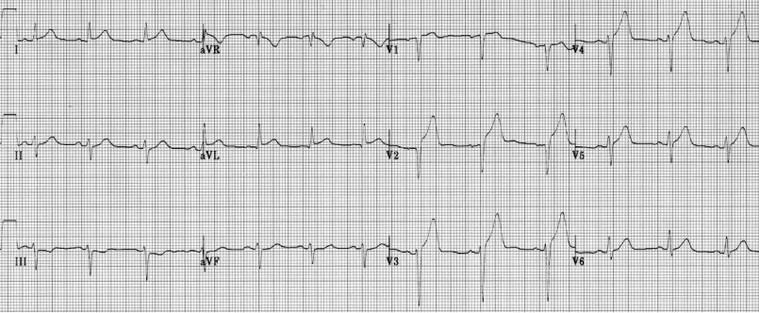
https://litfl.com/anterior-myocardial-infarction-ecg-library/

Appendix C: Facilitator Cheat Sheet & Debriefing Tips

NB: This is controversial and there are many potential ways to approach code blue in the suspected or confirmed COVID-19 patient. This case is based upon the covidcriticalcare.ca algorithm.

Here are two other algorithms for reference and discussion
- http://www.bccdc.ca/Health-Info-Site/Documents/COVID_Adult_CPR_Protocol.pdf
- https://www.resus.org.uk/media/statements/resuscitation-council-uk-statements-on-covid-19-coronavirus-cpr-and-resuscitation/covid-healthcare/

Objectives:
- Recognize a COVID risk patient and sequester and protect team with appropriate PPE
- Recognize and treat a STEMI that unexpectedly progresses to VF arrest
- Demonstrate effective communication and resource allocation in a COVID suspected patient requiring urgent intervention
- Demonstrate effective donning and doffing of PPE
- Utilize protective measures in a suspected COVID patient in cardiac arrest

Key moments to reflect on:
- Identification of possible COVID positive patient and considerations to room placement
- Utilization of appropriate PPE
- Initial management of STEMI
- Provider response to cardiac arrest
- Changes to routine ACLS care during a “Protected Code Blue”
- Preparing COVID patient for transfer
Sample questions for debriefing:
- Who should be present in the resuscitation room for these patients? How do we balance having the necessary personnel present while mitigating risk to the healthcare team/exposure?
- What personal protective equipment (PPE) must providers wear?
- What are next steps for staff members who may have been inadvertently exposed?
- What are the steps in decontaminating the room and equipment after a patient encounter such as this?
- What are the considerations for transfer of these patients to another department, such as the Cath Lab?
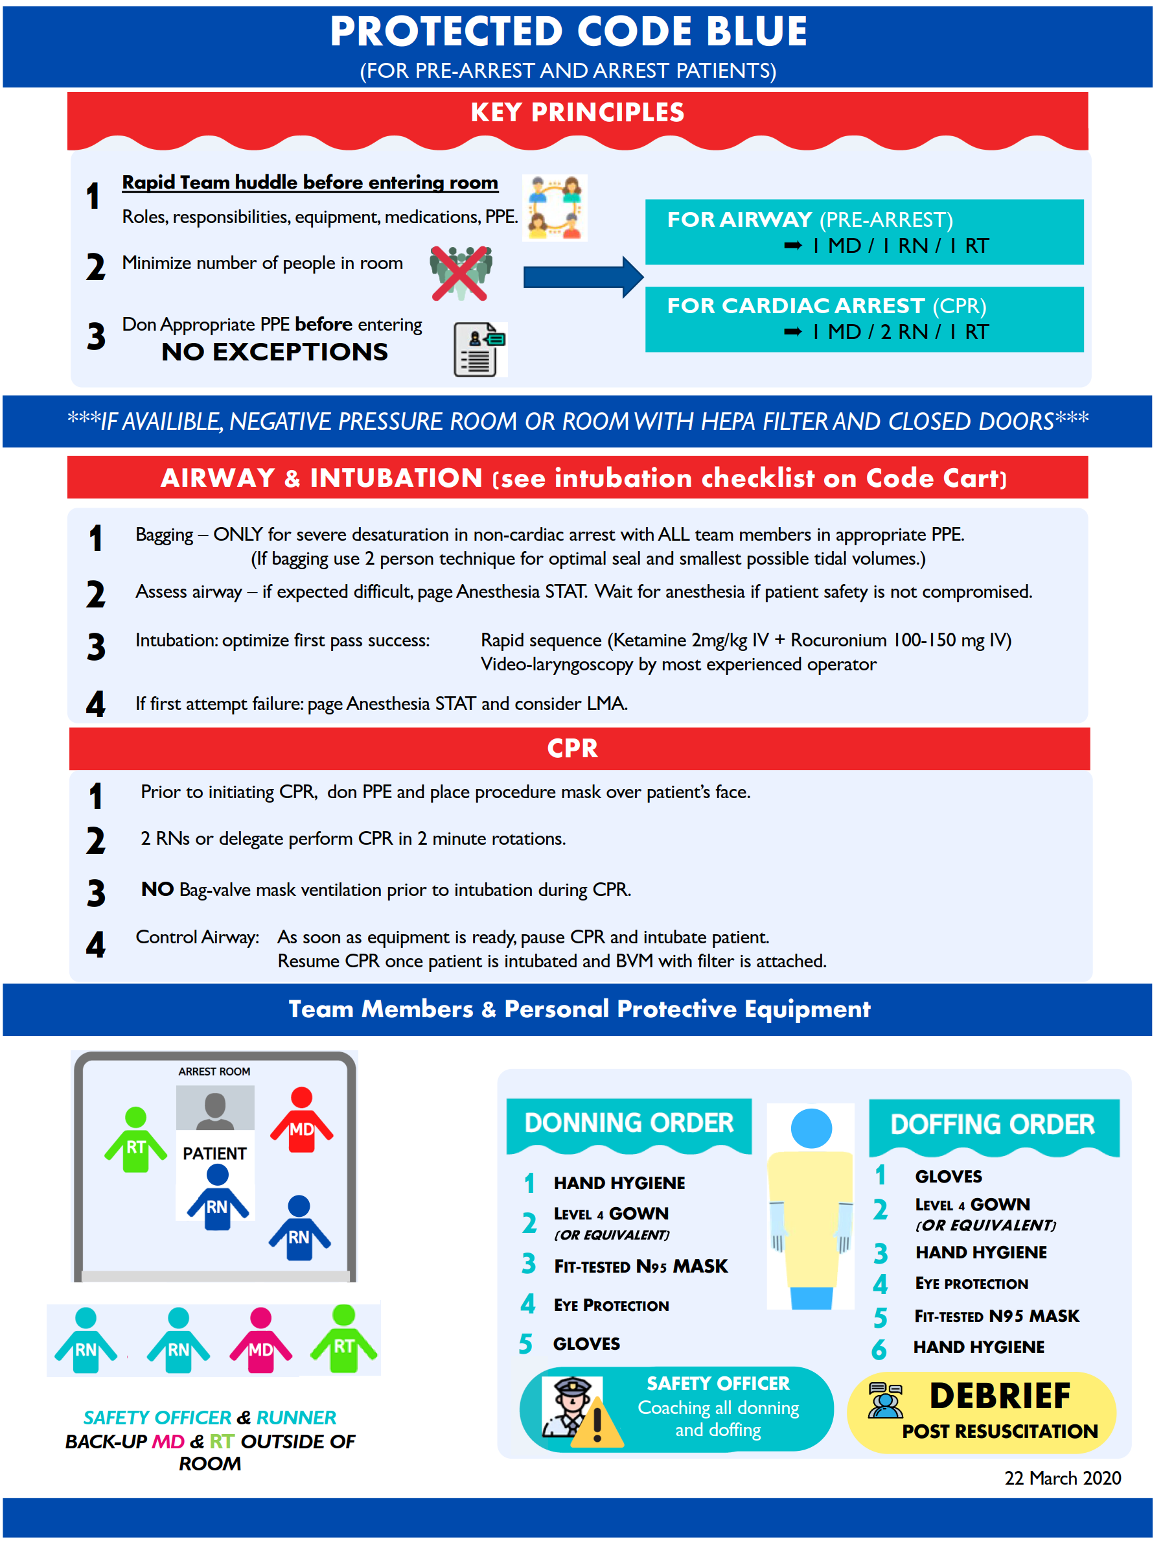

References

1. https://covidcriticalcare.ca/cardiac-arrest/
2. https://www.sim-one.ca/community/news/covid-19-simulations

